Specifications of Jigsaw machine (Multicut)

Sl | Specifications | Unit | Qtty | Rate | Total
1 | Longitudinal – 560mm  Passage – 65mm  Passage height 435 x 230mm  Saw table length x Width – 730 x 280mm  Soft wood – 65mm  Hard wood – 50mm  Copier – 15mm  Aluminium Bras, Silver - 10mm  Saw stroke – 2 Stokes, 19 and 12mm  Motor – 230V, 100Watt  Iron – 6-8mm  Plastic – 40mm  Foarm – 65mm  Weight – Approximately – 30 Kgs | No | 12

Hegner Multimax 22" Scrollsaw #22V - Wood Magazine
https://www.woodmagazine.com › saws › scrollsaws › h...

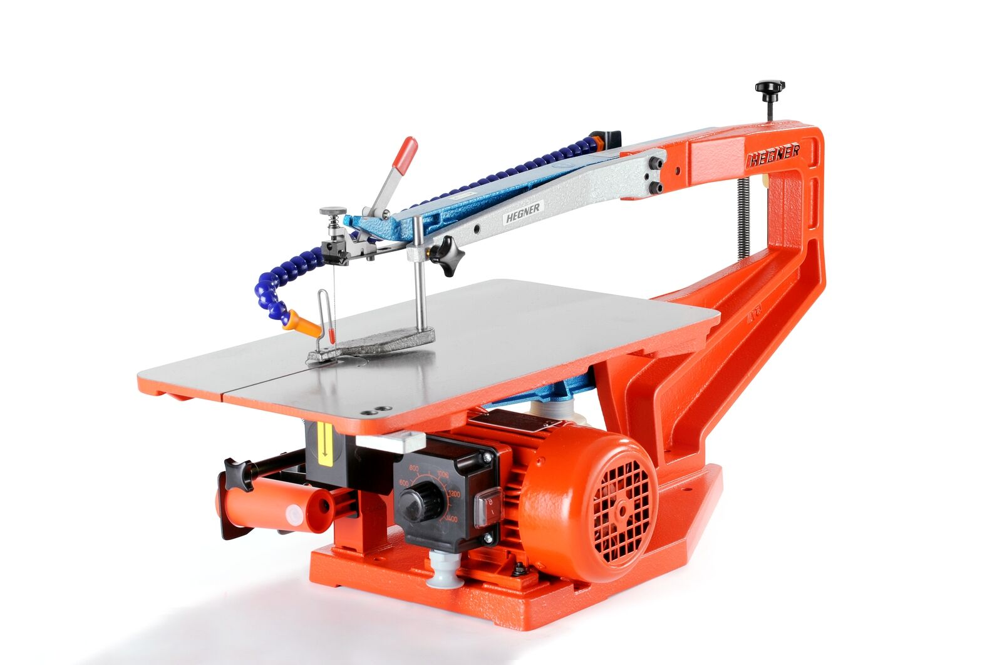
The HEGNER 22" Variable Speed saw features a large 22" capacity to handle virtually any project ... DEWALT DW788 1.3 Amp 20-Inch Variable-Speed Scroll Saw.

