PRESS RELEASE
Hundreds of Bhutanese trained as entrepreneurs in Dzongkhags
Promoting entrepreneurship in the wake of pandemic where many were laid off from jobs
Thimphu: The Labour Ministry is rolling out massive entrepreneurship training to aspiring participants in Dzongkhags which began in the wake of pandemic to create more self-employment. The training is being taken to dzongkhags so that it is convenient for participants to avail training within their own locality.
The 15-day basic entrepreneurship course (BEC) aims to prepare participants to develop business ideas, write ideas into business proposals, and manage and operate the proposed business. Participants ranged from those laid off from work for those who returned from overseas, having lost their job due to COVID-19 pandemic.
The training also aims to promote entrepreneurship culture among our people to create self-employment and generate more employment. There is overwhelming participation in dzongkhags with majority being females. The training has attracted unemployed participants who have often not made through the job interviews, but are determined to operate their own business.
The entrepreneurship training is expected to give rise to at least two to three startups from every batch of training. The Ministry will provide handholding support to these startups to materialize their business proposals with financial and resource support from various stakeholders.
Trainings are already completed in Thimphu, Haa, Trashigang, and Trashiyangtse dzongkhags with Bumthang and Zhemgang currently hosting the trainings. The training is facilitated by the Department of Employment & Human Resources, under the Ministry of Labour & Human Resources, in collaboration with Thimphu TechPark Ltd., Respect Educate Nurture and Empower Women (RENEW) and host dzongkhags.

Some highlights of the Course conducted in the Dzongkhags:
- Haa Dzongkhag
Course Date: 01-16 December 2020
Total participants: 17 (Female-10, M-7)
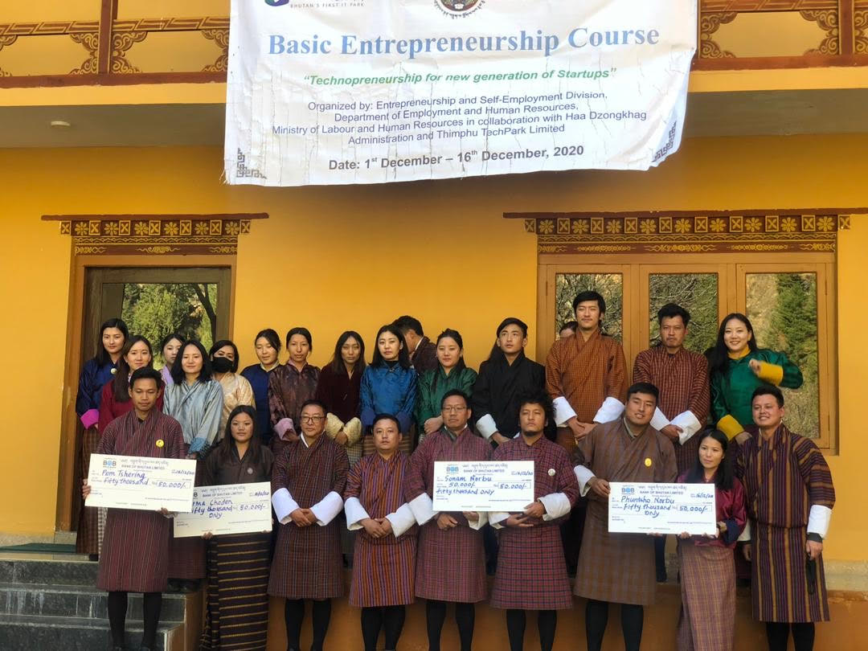
- Trashigang Dzongkhag
Course Date: 19th February-08th March 2021
Total participants: 27 (F-9, M-18))

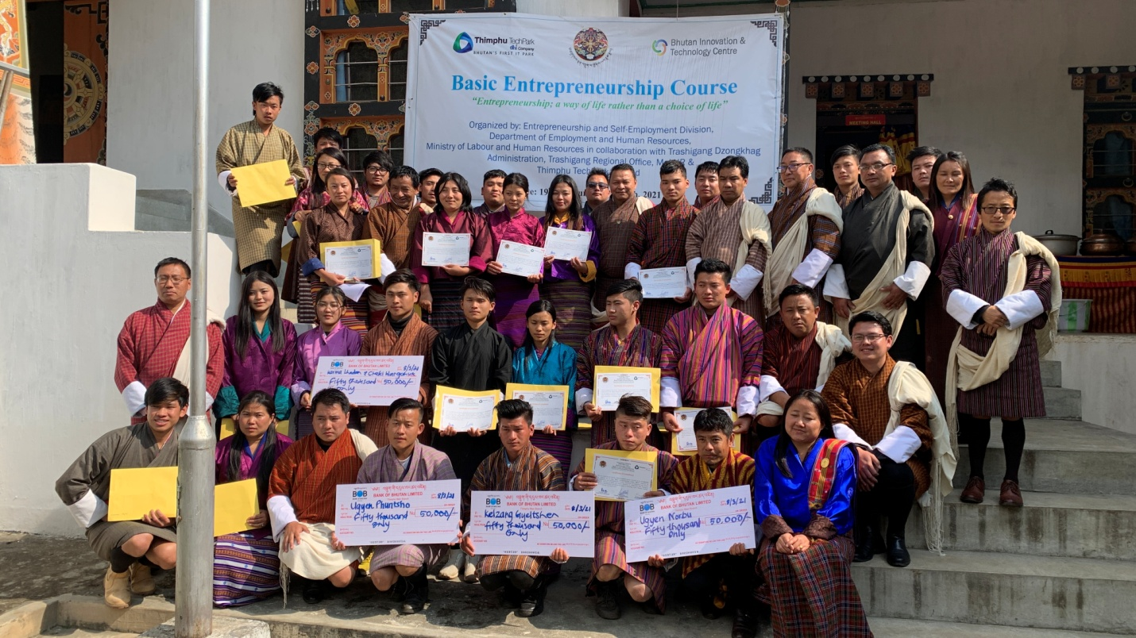

- Trashiyangtse Dzongkhag
Course Date: 03rd March-19th March 2021
Total participants: 25 (F-23, M-3)

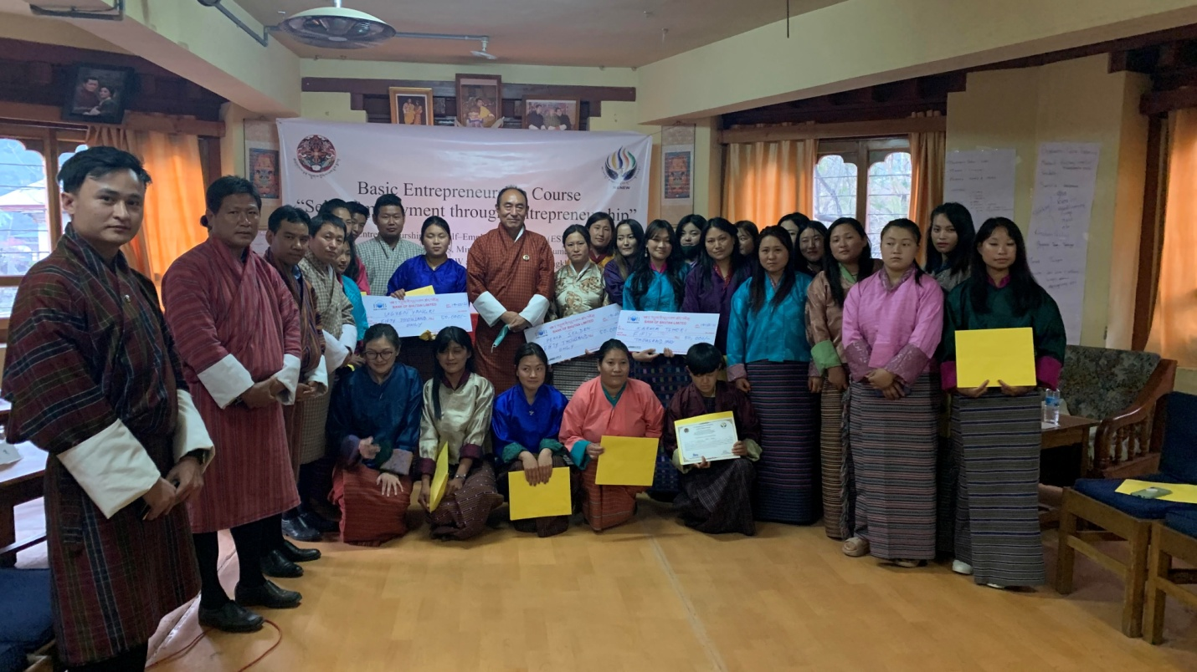

- Bumthang Dzongkhag
Course Date: 15th -31st March 2021
Total participants: 27 (F-18, M-9)

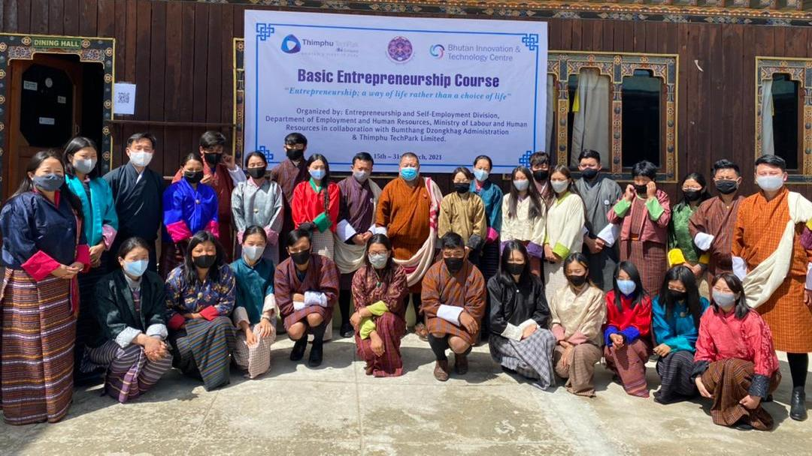

- Zhemgang Dzongkhag
Course Date: 22nd March -07th April 2021
Total participants: 25 (F-14, M-11)

